Two Day Club Cricket

1.1 Team scores over 200, under 100 since 1985/86 season.

Two day scores over 200 under 100 as %
0.00
10.00
20.00
30.00
40.00
50.00
85/86
88/89
91/92
94/95
97/98
00/01
03/04
06/07
Over 200
Under 100

Although there were 30 scores over 200 (cf 38 in 2007/08), as a percentage of innings
there was a slight increase from 31% to 33%.
5 scores under 100, (cf 6 in 2007/08), so a slight increase from 4.9% to 5.5%.
There were only 91 innings in 2008/09 which is by far the lowest since my records began in 1985/86. The highest number in a season was 179 in 1990/91 and it is only from 1997/98 that the number of innings has dropped.

1.2 Results and declarations as a percentage of matches and innings.

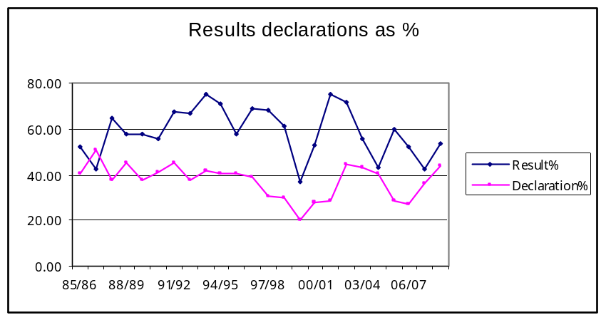

There were 14 results which is a marked increase but note the increase in declarations
from 36% to 44% of innings to achieve that figure.

1.3 Competition points since 1960/61

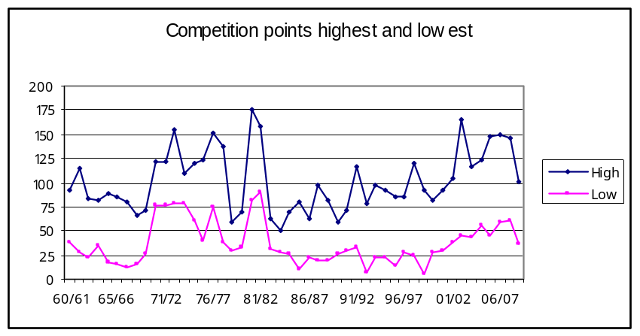
The difference in points between the first and last placed team has widen this past season.

1.4 Percentage differential of points from first to last.

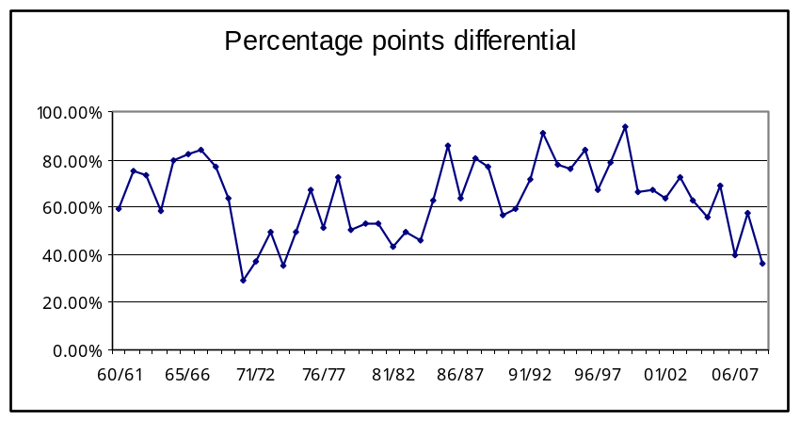
This shows more clearly the difference between the top team and the bottom team for the
2008/09 season and at a percentage differential of 36% it is one of the lowest recorded since 1960/61.

One Day Club Cricket

2.1 Team scores over 200, under 100 since 1985/86 season.
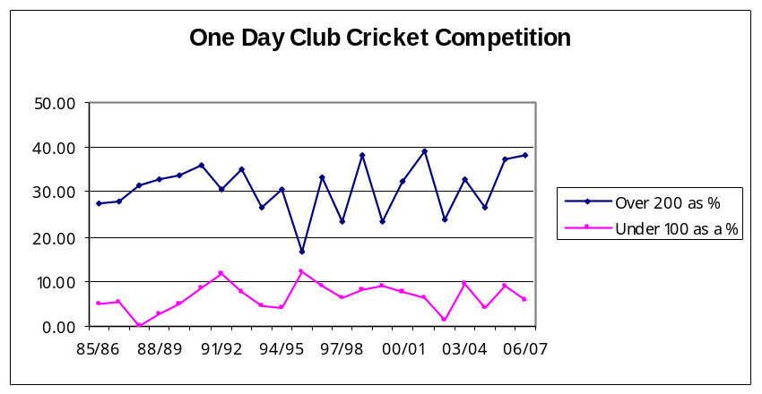
There was 25 scores over 200, (cf 26 in 2007/08) and 5 scores under 100,
(cf 4 in 2007/08), so very little difference over the past two seasons.

2.2 Scores over 200 compared for 2 and 1 day competition.

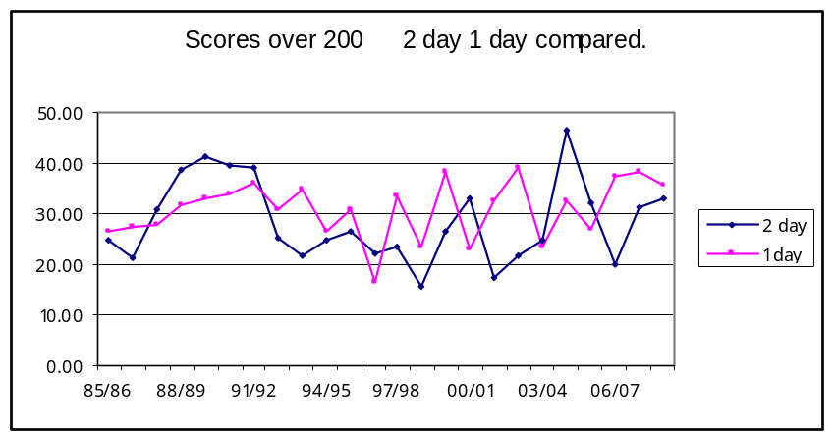
Over the past 23 seasons there has been 14 occasions when there were more
scores over 200 achieved in the one day competition.

